

**Faculty of engineering - Shoubra**

**Benha University**

**Research Article / Research Project / Literature Review**

in fulfillment of the requirements of

|  |  |
| --- | --- |
| **Department** | **Engineering Mathematics and Physics** |
| **Division** |  |
| **Academic Year** | **2019-2020 Preparatory** |
| **Course name** | **Computer** |
| **Course code** | **ECE006** |
| **Date** |  |

**Title: -**

**Artificial intelligence**

By:

|  |  |  |  |
| --- | --- | --- | --- |
|  | Name | Edu mail | B.N |
| 1 | مؤمن ناصر اسعد إسماعيل راشد | [Moamen196077@feng.bu.edu.eg](mailto:Moamen196077@feng.bu.edu.eg) | 960 |

**Approved by:**

|  |  |
| --- | --- |
| Examiners committee | Signature |
| Dr.Ahmed Bayoumi |  |
| Dr.Shady Elmashad |  |
| Dr. Abdelhamid Attaby |  |

|  |  |
| --- | --- |
| Github link |  |
| Github page |  |

**Application brief**

Artificial intelligence is the science and engineering of the machine industry, especially smart computer software.  Artificial intelligence studies mental capabilities by using computational models.  It makes the computer do things that people do better.

The artificial field is of great importance in many fields. For example in the field of medicine, where artificial intelligence predicts ICU conversions, medical examination, and disease knowledge. It is of great importance in the field of business as it helps to enhance business capabilities and contribute to its development.

Artificial intelligence aims to repeat human intelligence, solve the problem of intensive tasks. And making a smart connection between perception and action, improving human contact with the computer.

**Screenshots**

**Main page:**

**Coding:**

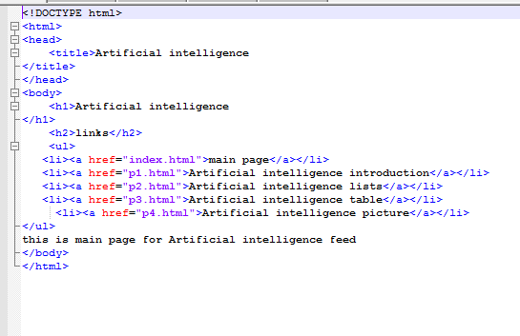

**Running:**

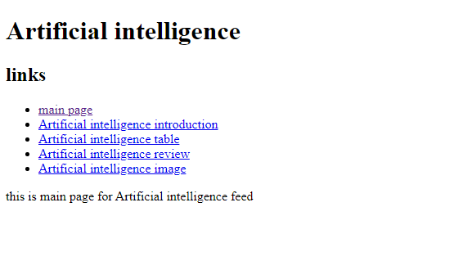

**Artificial intelligence introduction page:**

**Code:**

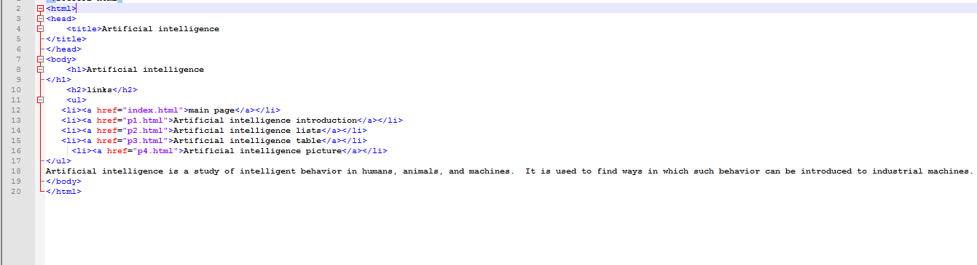

**Running:**

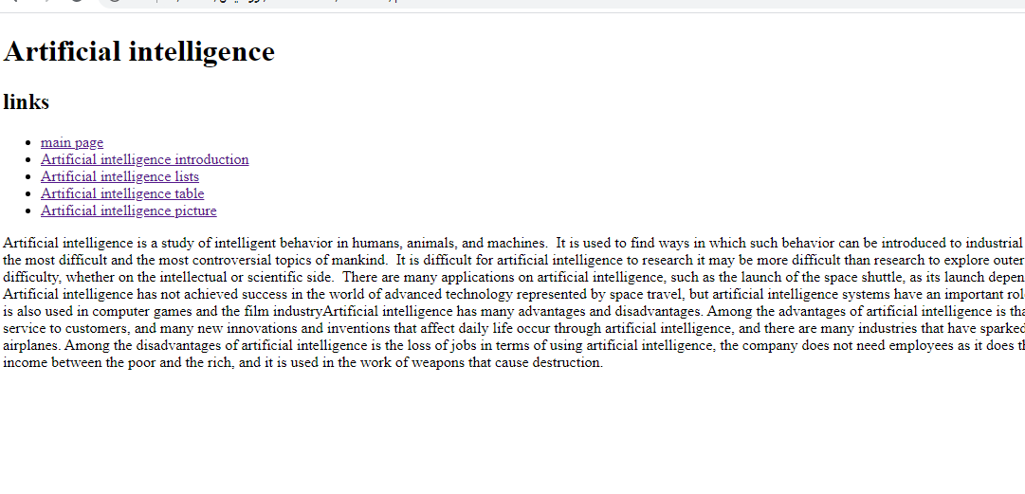

**Artificial intelligence table page:**

**Code:**

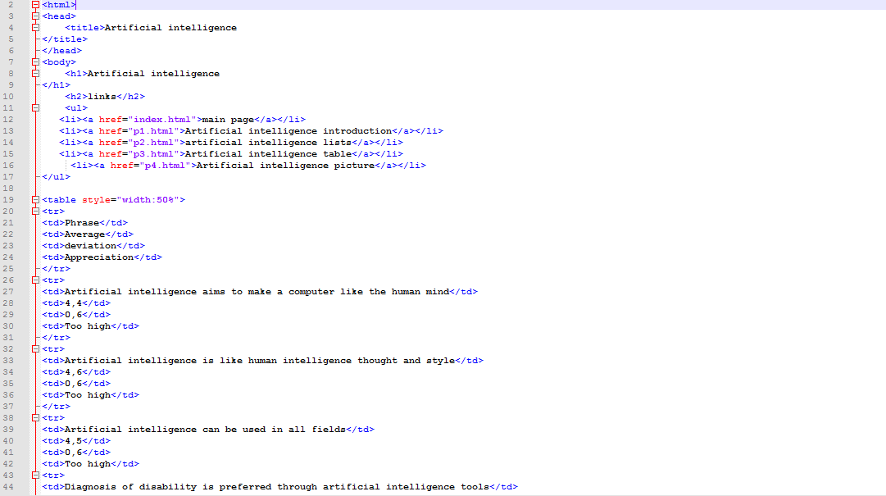

**Running:**

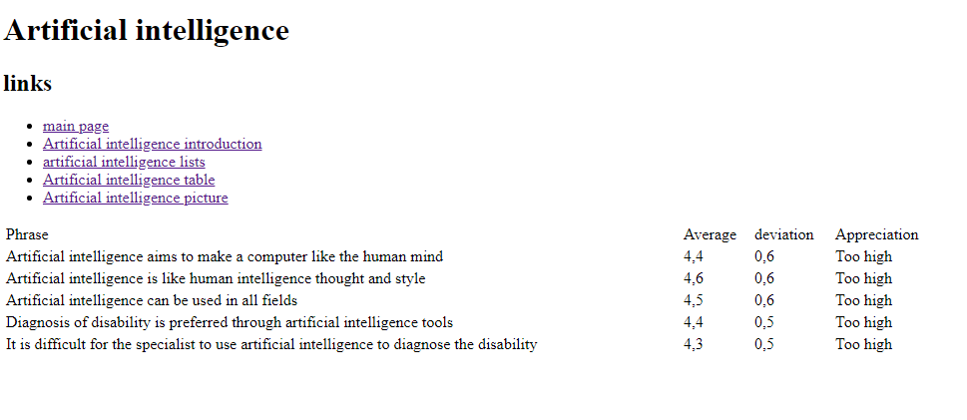

**Artificial intelligence list page:**

**Code:**

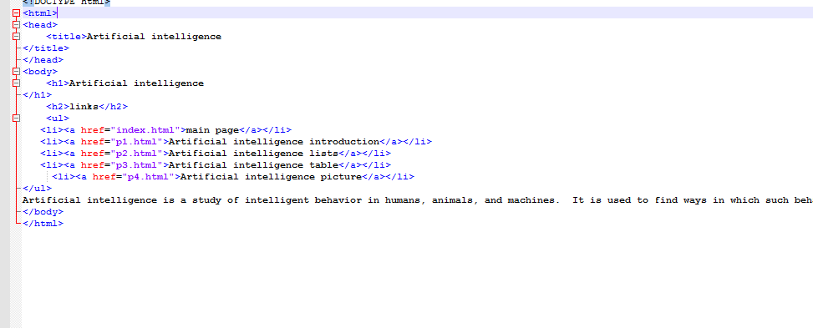

**Running:**

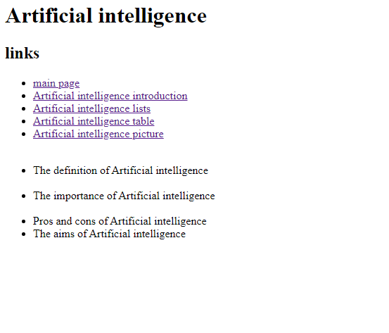

**Artificial intelligence Picture:**

**Code:**

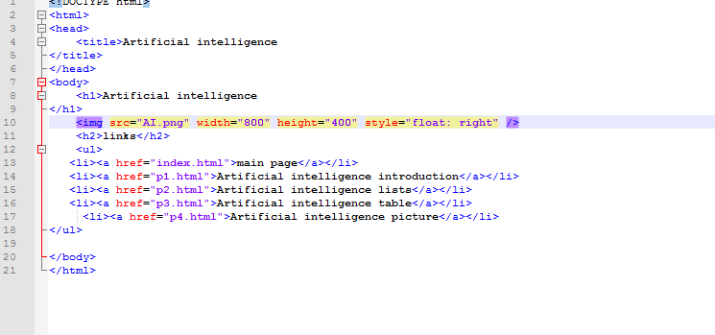

**Running:**

